**Software Requirements Specifications (SRS)**

**ERP Solution for Lakhsma Sweater Ltd.**

REFERENCE: GW/ERP/SRS/

**Version: 1.1**

**Date of Release: May 16, 2016**



**Genweb2 Limited**

TK Bhaban (11th Floor),

13 Kazi Nazrul Islam Avenue,

Kawran Bazar, Dhaka 1215, Bangladesh

web: [http://www.genweb2.com](http://www.genweb2.com/)

**Contents**

Document Release History 4

1.0 Introduction 5

1.1 Purpose of SRS 5

2.0 Production Planning 6

2.1 Overview 6

2.2 Functional features of Merchandiser modules are given below (actor wise) 7

2.3 Production Planning Process flow 8

2.4 User Class 8

3.0 Production Planning Process Flow: 9

3.1 Production Planning Process details: 9

4.0 USE CASE Diagram 11

4.1 Knitting Machine wise Block Creation Process 11

4.2 Calendar Preparation process: 11

4.3 Style Study Process: 12

4.4 Buyer Work Order Receive Process: 12

4.5 Production Planning Process: 13

5.0 USE CASE Details 14

5.1 UC/PP/001/Declaration of Production Process: 14

5.2 UC/PP/002/Gauge Wise Machine Block Declaration: 15

5.3 UC/PP/003/Organizational Calendar Preparation: 16

5.4 UC/PP/004/ Knitting Machine Block wise Calendar Preparation: 17

5.5 UC/PP/005/ Style Study Declaration: 18

5.6 UC/PP/006/ Receive Export PO: 19

5.7 UC/PP/007/ Production Planning: 20

6.0 Production planning mock-up 22

6.1 Production Planning master user interface mock-up 22

6.1.1 Production Process: 22

6.1.2 Gauge Wise Machine Block: 23

6.1.3 Organizational General Calendar: 24

6.1.4 Machine Block Wise Calendar: 25

6.2 Production Planning Operational user interface mock-up 26

6.2.1 Style Study 26

6.2.2 Buyer Work Order 27

6.2.3 Planning Board 28

Document Release History

| Sl. No. | Version Number | Release Date | Prepared By | Reviewed By | Approved By | Reasons for New Release |
| --- | --- | --- | --- | --- | --- | --- |
| 1 | 1.0 | 16 March, 2016 | Md. Assalatuzzaman |  | N/A |  |
| 2 | 1.1 | 16 May, 2016 | Md. Assalatuzzaman |  | N/A |  |

# Introduction

## Purpose of SRS

The purposes of this SRS are to clearly identify the customer requirements and provide a detailed document. The customer will review the document and approve/make change as required. It will also help the review team to be able to validate whether the customer requirements has been fulfilled.

The SRS will also help the Analyst and Designer to understand and track the Requirements for the proposed system. It will also identify a set of requirements for the Development of the project. The SRS helps to describe the behavior of the system to be developed.

# Production Planning

## Overview

Production planning and Control department is one of the important department for the apparel manufacturing company. In the context of the apparel manufacturing primary roles of the Production Planning and Control (PPC) department has been listed below. Each functions has been explained briefly just overview about the task.  To know details about the task read related articles.

Loading production: Planner defines which style to be loaded to the production line and how much quantity to be loaded.

Process selection & planning: Processes needed to complete an order vary style to style. According to the order (customer) requirement PPC department select processes for the orders. Sometime extra processes are eliminated to reduce cost of production.

Facility location: Where a company has multiple factories (facilities) for production and factories are set for specific product, planner need to identify which facility will be most suitable for new orders. Sometimes there may be a capacity shortage in a factory, in that case planner need to decide which facility will selected for that orders.

Estimating quantity and costs of production: Planner estimate daily production (units) according to the styles work content. With the estimated production figure, production runs and manpower involvement planner also estimate production cost per pieces.

Capacity planning: PPC department plays a major role during order booking. They decide (suggest) how much order they should accept according to their production capacity. Allocating of total capacity or deciding how much capacity to be used for an order out of total factory capacity. Regularly updating factories current capacity (production capacity).

Machine Block planning: Preparing detailed line planning with daily production target for the production knitting Machine Block. Most cases Knitting Machine Block planning is made after discussing with production team and Industrial engineers.

Follow up and execution: Whatever plan is made is executed by PPC department. PPC department keeps close look whether everything is progressing according the plan. Chasing other department heads on daily basis to keep plan on track. They update order wise completed tasks on the Time & action Calendar.  When they found something is going to be late they expedite and create an alarm about the delay.

## Functional features of Merchandiser modules are given below (actor wise)

* Automatic & Intelligent Planning Process
* Interactive Graphical presentation of Planning Board
* Day & Week wise loading view
* Proper Line/Block wise Planning
* Production Overtime planning
* Learning Curve is considered here
* Other Process Loading Plan
* Raw materials planning mapping
* Critical Resource Planning & Utilization
* Style Criticality handle
* Early by Late by indication
* Real-time Production Update

## Production Planning Process flow

Production planning process flow consists:

* Defining Production Process
* Create Gauge wise machine Block
* Organizational General calendar Preparation
* Machine Block wise Calendar Preparation
* Style Study
* Receive Buyer Work Order
* Auto Schedule Production Plan

## User Class

| **User Class / Actor** | **Characteristics** | **Responsibilities** |
| --- | --- | --- |
| Production Manager | * Add, modify Knitting Machine Block * Add, modify Organizational Calendar * Add, modify Knitting Machine Block Wise Calendar | * Add, modify documents * Maintain other documents related information |
| Sample Manager | * Add, modify Style Study | * Add, modify documents * Maintain other documents related information |
| Merchandiser | * Add, modify export order | * Add, modify documents * Maintain other documents related information |
| Planning Manager | * Schedule Production Plan * Modify Planning Information | * Add, modify documents * Maintain other documents related information |
| Super admin | * Can do any jobs in system | * Add, modify and delete all information. * Give permission to all users and documents. * Manage the user authentication layer. * Create & assign role to users. * Manage application security. * Manage application settings. |

# Production Planning Process Flow:

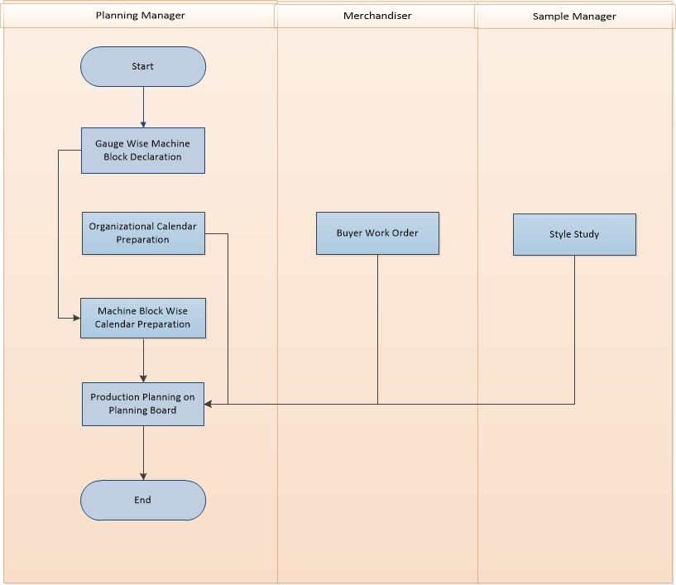

Fig: Production Planning Process

## Production Planning Process details:

**Configuration:**

**Production Process:** All Processes and Sub Processes will be declared here in this Production Process Interface, and those will be used in Style Study as require for any certain style.

**Line/Block:** Block or line will have number of same gauge machine for Knitting

**General Calendar:** this is the standard organizational calendar for working hour, working days, Weekend etc.

**Line/Block wise Calendar:** This is line/block specific calendar for working hour, working days, Weekend etc.

**Production Planning Process by Steps:**

**Style Study:** All technical specification and process wise production study will be declared here in Style Study. Eventually priority will be added here in incremental ratio to last one.

**Buyer Work Order:** Order from buyer will be recorded here along with size and color breakdown. More over tolerance percentage will be also in consideration to ensure the maximum shipment possibility

**Planning Board:** It is an Automatic intelligent Planning Board for knitting process. Other process like Linking, Trimming, Mending, Washing, and Finishing will be planned based on the Knitting plan considering the Style Study declaration in Style. System will use the artificial intelligence to plan all the orders in maximum optimum way where system will try to utilize the full production capacity and off course will make sure to utilize the learning curve. System planning intelligence will find out the other process after knitting and based on the study it will multiply with the order quantity and deduct the days from in-house inspection date and will plan for knitting. In Planning Board it left side there will be all Line/Block and orders booked for the line/Block and date will be shows as stripe. System will utilize the intelligence based on the declaration of the Productivity, Organizational efficiency, First day output, Incremental logic and maximum output and off course the priority declared by the planner. System will be intelligent enough to display any order/stripe by color where it will indicate whether it is on time or late. How many days early by or late by will be also displayed in planning board so that the planner can take decision if he/she wants to optimize it. There will be a notification corner also where system will guide how planner may make the planning process more optimum. Please keep a note that any running order will be freeze to move any change or shift line/block. It may shift the day to onwards for the pending quantity.

# USE CASE Diagram

## Knitting Machine wise Block Creation Process

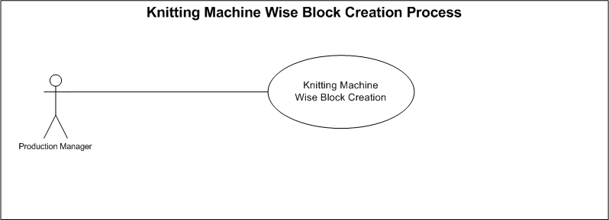

Fig: Knitting Machine wise Block Creation Process

## Calendar Preparation process:

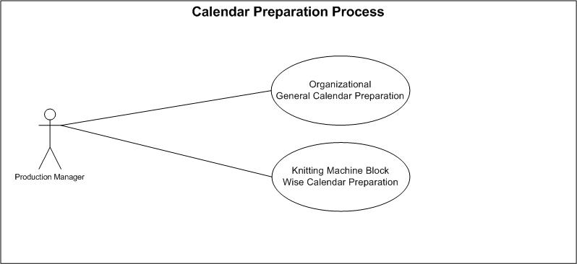

Fig: Calendar Preparation Process

## Style Study Process:

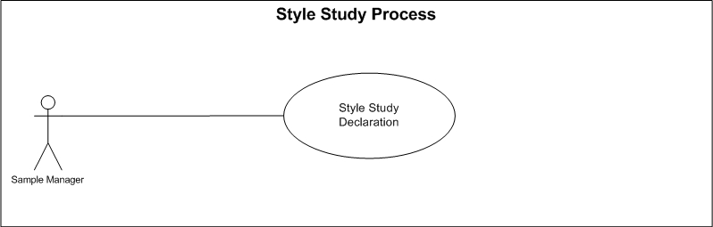

Fig: Style Study Process

## Buyer Work Order Receive Process:

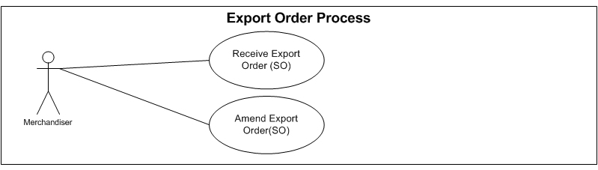

Fig: Buyer Work Order Process use case

## Production Planning Process:

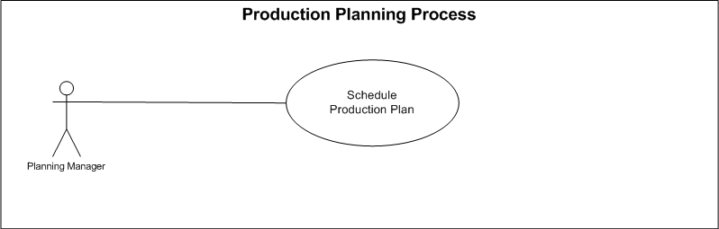

Fig: Production Planning Process

# USE CASE Details

## UC/PP/001/Declaration of Production Process:

|  |  |  |
| --- | --- | --- |
| Use Case ID: UC/PP/001 | | |
| Use Case Name**: Declaration of Production Process** | | |
| Created By: **GenWeb2 Ltd.** | | Date Created: 16 March, 2016 |
| Actors: | * Production Manager | |
| Trigger: | When Production manager declare all the production process exist in organization | |
| Business Rule | * Production Manager will declare all the production Process exist in the organization * Related Production Process will be used in Style Study as require for any certain style | |
| Description: | All Processes and Sub Processes will be declared here in this Production Process Interface, and those will be used in Style Study as require for any certain style | |
| Frequency of Use | * Medium | |
| Preconditions | * N/A | |
| Post conditions | * Appropriate message will be displayed after each entry being saved / updated. * Production Process will be saved in System * Production process will be available to select in Style Study | |
| Assumption | Production processes are already well defined for organization | |
| Goal | To Record all the production processes in system. | |
| Normal Flow | Production manager insert all the Production Processes in system | |
| Alternate Flow | * N/A | |
| Exception | * Proper message should be displayed if Production Process can’t be saved. * Proper message should be displayed if any master or dependent data is missing or not found. * Appropriate message should be displayed if mandatory fields are not filled. * Any system exception/Application exception should be handled centrally with proper user message during the page browse/save/update/view operations. | |
| Cross Reference | * N/A | |

## UC/PP/002/Gauge Wise Machine Block Declaration:

|  |  |  |
| --- | --- | --- |
| Use Case ID: UC/PP/002 | | |
| Use Case Name**: Gauge wise Machine Block Declaration** | | |
| Created By: **GenWeb2 Ltd.** | | Date Created: 16 March, 2016 |
| Actors: | * Production Manager | |
| Trigger: | When Production Manager declare Gauge wise machine block | |
| Business Rule | * Production Manager will declare all the Gauge wise machine block as convenient or require * Production Planning will take place according to Gauge wise machine block | |
| Description: | Production Manager will declare Block number of same gauge machine for Knitting and System will plan the production against the block | |
| Frequency of Use | * Medium | |
| Preconditions | * N/A | |
| Post conditions | * Appropriate message will be displayed after each entry being saved / updated. * Gauge wise machine block will be saved in system | |
| Assumption | Gauge wise machine block concept already in practice | |
| Goal | To create Gauge wise machine block in System for smooth production planning | |
| Normal Flow | * Production Manager will declare Block number of same gauge machine for Knitting * System will plan the production against the block | |
| Alternate Flow | * N/A | |
| Exception | * Proper message should be displayed if Gauge wise Machine Block can’t be saved. * Proper message should be displayed if any master or dependent data is missing or not found. * Appropriate message should be displayed if mandatory fields are not filled. * Any system exception/Application exception should be handled centrally with proper user message during the page browse/save/update/view operations. | |
| Cross Reference | * N/A | |

## UC/PP/003/Organizational Calendar Preparation:

|  |  |
| --- | --- |
| Use Case ID: UC/PP/003 | |
| Use Case Name**: Organizational Calendar Preparation** | |
| Created By: **GenWeb2 Ltd.** | Date Created: 16 March, 2016 |
| Actors: | * Production Manager |
| Trigger: | When Production Manager prepare Organizational Yearly Calendar considering Weekend & Holiday |
| Business Rule | * Production Manager will prepare the Organizational Yearly Calendar considering Weekend & Holiday * This General Calendar will be used for general planning |
| Description: | Production Manager will declare the standard organizational calendar for working Minutes, working days, Weekend etc. |
| Frequency of Use | Medium |
| Preconditions | * N/A |
| Post Conditions | * Appropriate message will be displayed after each entry being saved / updated. * Organizational General Calendar will be saved with standard working minutes, Weekend and Holidays |
| Assumption | Organization already in practice of Organizational General Calendar |
| Goal | Declare Organizational Calendar in system along with standard working minutes, Weekend and holidays |
| Normal Flow | * Production Manager will prepare the Organizational Yearly Calendar considering Weekend & Holiday * This General Calendar will be used for general planning |
| Alternate Flow | N/A |
| Exception | * Proper message should be displayed if Organizational General Calendar can’t be saved. * Proper message should be displayed if any master or dependent data is missing or not found. * Appropriate message should be displayed if mandatory fields are not filled. * Any system exception/Application exception should be handled centrally with proper user message during the page browse/save/update/view operations. |
| Cross Reference | * N/A |

## UC/PP/004/ Knitting Machine Block wise Calendar Preparation:

|  |  |  |
| --- | --- | --- |
| Use Case ID: UC/PP/004 | | |
| Use Case Name**: Knitting Machine Block wise Calendar Preparation** | | |
| Created By: **GenWeb2 Ltd.** | | Date Created: **16 March 2016** |
| Actors: | Production Manager | |
| Trigger: | When Production Manager prepare specific knitting machine block wise calendar. | |
| Business Rule | * Production Manager prepare Knitting Machine Block wise specific calendar considering the standard Working Minutes, Weekend, Holidays etc. * Every individual knitting machine block will be followed by this specific block wise calendar. * Knitting Production Planning will be done based on this Block wise Calendar | |
| Description: | This is line/block specific calendar for working hour, working days, Weekend etc. Production Manager prepare Knitting Machine Block wise specific calendar considering the standard Working Minutes, Weekend, Holidays etc. Every individual knitting machine block will be followed by this specific block wise calendar. Knitting Production Planning will be done based on this Block wise Calendar | |
| Frequency of Use | Medium | |
| Preconditions | * N/A | |
| Post conditions | * Appropriate message will be displayed after each entry being saved / updated. * Knitting Machine Block wise Calendar will be saved In System. * System will Plan the Knitting production based on this Knitting Machine block wise Calendar. | |
| Assumption | N/A | |
| Goal | * To prepare more specific calendar for machine block | |
| Normal Flow | * Production Manager prepare Knitting Machine Block wise specific calendar considering the standard Working Minutes, Weekend, Holidays etc. * Every individual knitting machine block will be followed by this specific block wise calendar. * Knitting Production Planning will be done based on this Block wise Calendar | |
| Alternate Flow | * N/A | |
| Exception | * Proper message should be displayed if Knitting Machine Block Wise Calendar can’t be saved. * Proper message should be displayed if any master or dependent data is missing or not found. * Appropriate message should be displayed if mandatory fields are not filled. * Any system exception/Application exception should be handled centrally with proper user message during the page browse/save/update/view operations. | |
| Cross Reference | * N/A | |

## UC/PP/005/ Style Study Declaration:

|  |  |  |
| --- | --- | --- |
| Use Case ID: UC/PP/005 | | |
| Use Case Name**: Style Study Declaration** | | |
| Created By: **GenWeb2 Ltd.** | | Date Created: **16 March 2016** |
| Actors: | Sample Manager | |
| Trigger: | When Sample Manager declare the style study details by operation and process | |
| Business Rule | * Sample Manager will record the Style study by operation & Process * Production Planning will take place based on the style study considering the Buyer Work Order quantity | |
| Description: | All technical specification and process wise production study will be declared here in Style Study. Eventually priority will be added here in incremental ratio to last one. System will plan based on the study considering the Buyer Work Order quantity | |
| Frequency of Use | high | |
| Preconditions | * Style Must Exist * Production Process Must Exist | |
| Post conditions | * Appropriate message will be displayed after each entry being saved / updated. * Style Study will be saved In System. * System will Plan the process wise production based on this style study considering the Buyer Work Order quantity | |
| Assumption | N/A | |
| Goal | * To record the style wise study in system for automatic production Planning | |
| Normal Flow | * Sample Manager will record the Style study by operation & Process * Production Planning will take place based on the style study considering the Buyer Work Order quantity | |
| Alternate Flow | * N/A | |
| Exception | * Proper message should be displayed if Style Study can’t be saved. * Proper message should be displayed if any master or dependent data is missing or not found. * Appropriate message should be displayed if mandatory fields are not filled. * Any system exception/Application exception should be handled centrally with proper user message during the page browse/save/update/view operations. | |
| Cross Reference | * N/A | |

## UC/PP/006/ Receive Export PO:

|  |  |  |
| --- | --- | --- |
| Use Case ID: UC/PP/006 | | |
| Use Case Name**: Receive Export PO** | | |
| Created By: **GenWeb2 Ltd.** | | Date Created: **16 March 2016** |
| Actors: | Merchandiser | |
| Trigger: | When Merchandiser receive export PO(sales order) from buyer | |
| Business Rule | * Buyer gives the Export Purchase Order after quotation finalization. * Export Order contains details Color and size wise order quantity, Unit of measurement, rate, Currency, Shipment Date, Shipment Destinations, Shipping Mode, HS Code, tolerance, Delivery Terms, Technical specification etc. * Finalize the export purchase order | |
| Description: | Buyer gives the Export Purchase Order after quotation finalization. Export Order contains details Color and size wise order quantity, Unit of measurement, rate, Currency, Shipment Date, Shipment Destinations, Shipping Mode, HS Code, tolerance, Delivery Terms, Technical specification etc. | |
| Frequency of Use | Medium | |
| Preconditions | * Confirm style have to exist * Quotation have to be accepted by buyer | |
| Post conditions | * N/A | |
| Assumption | * N/A | |
| Goal | Create a sales order in the system | |
| Normal Flow | * Buyer gives the Export Purchase Order after quotation finalization. * Export Order contains details Color and size wise order quantity, Unit of measurement, rate, Currency, Shipment Date, Shipment Destinations, Shipping Mode, HS Code, tolerance, Delivery Terms, Technical specification etc. * Finalize the export purchase order | |
| Alternate Flow | * N/A | |
| Exception | * N/A | |
| Cross Reference | * N/A | |

## UC/PP/007/ Production Planning:

|  |  |  |
| --- | --- | --- |
| Use Case ID: UCD/PP/007 | | |
| Use Case Name**: Production Planning** | | |
| Created By: **GenWeb2 Ltd.** | | Date Created: **16 March 2016** |
| Actors: | Planning Manager | |
| Trigger: | When Planning Manager Plan production in System. | |
| Business Rule | * Planning manager will Plan automatic Production planning based on the Block wise Calendar, Style Study and Buyer work order quantity. * Production will be followed by the Production Planning | |
| Description: | It is an Automatic intelligent Planning Board for knitting process. Other process like Linking, Trimming, Mending, Washing, and Finishing will be planned based on the Knitting plan considering the Style Study declaration in Style. System will use the artificial intelligence to plan all the orders in maximum optimum way where system will try to utilize the full production capacity and off course will make sure to utilize the learning curve. System planning intelligence will find out the other process after knitting and based on the study it will multiply with the order quantity and deduct the days from in-house inspection date and will plan for knitting. In Planning Board it left side there will be all Line/Block and orders booked for the line/Block and date will be shows as stripe. System will utilize the intelligence based on the declaration of the Productivity, Organizational efficiency, First day output, Incremental logic and maximum output and off course the priority declared by the planner. System will be intelligent enough to display any order/stripe by color where it will indicate whether it is on time or late. How many days early by or late by will be also displayed in planning board so that the planner can take decision if he/she wants to optimize it. There will be a notification corner also where system will guide how planner may make the planning process more optimum. Please keep a note that any running order will be freeze to move any change or shift line/block. It may shift the day to onwards for the pending quantity. | |
| Frequency of Use | Medium | |
| Preconditions | * Style Must Exist * Export PO Must Exist * Knitting Machine Block wise Calendar Must Exist * Style Study Must Exist | |
| Post conditions | * Appropriate message will be displayed after each entry being saved / updated. * Production Planning will be saved in System. * Produced quantity will be reduced from the planning board. | |
| Assumption | * Organization already in practice of Production Planning | |
| Goal | To ensure effective Production Planning | |
| Normal Flow | * Planning manager will Plan automatic Production planning based on the Block wise Calendar, Style Study and Buyer work order quantity. * Production will be followed by the Production Planning | |
| Alternate Flow | * N/A | |
| Exception | * Proper message should be displayed if Production Planning can’t be saved. * Proper message should be displayed if any master or dependent data is missing or not found. * Appropriate message should be displayed if mandatory fields are not filled. * Any system exception/Application exception should be handled centrally with proper user message during the page browse/save/update/view operations. | |
| Cross Reference | * Use Case ID: UCD/PP/002 * Use Case ID: UCD/PP/004 * Use Case ID: UCD/PP/005 * Use Case ID: UCD/PP/006 | |

# Production planning mock-up

## Production Planning master user interface mock-up

### Production Process:

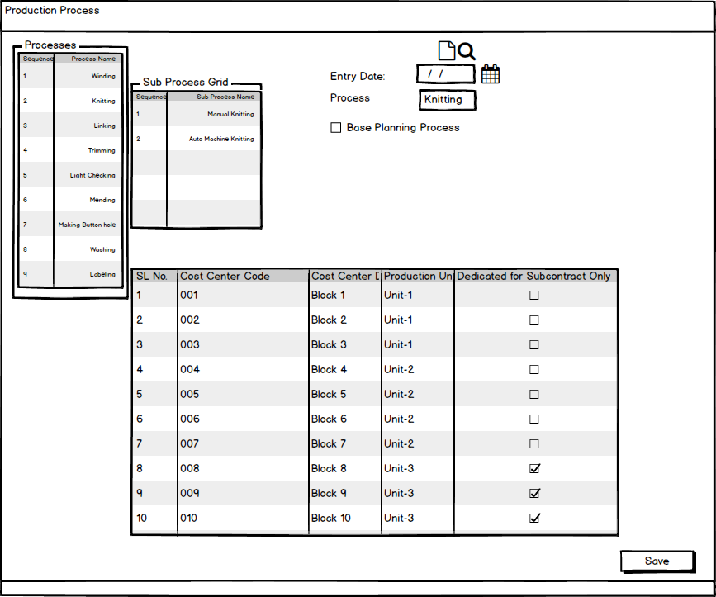

Fig: Production Process

### Gauge Wise Machine Block:

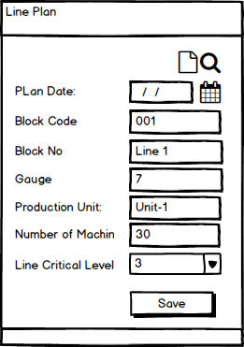

Fig: Gauge wise machine block

### Organizational General Calendar:

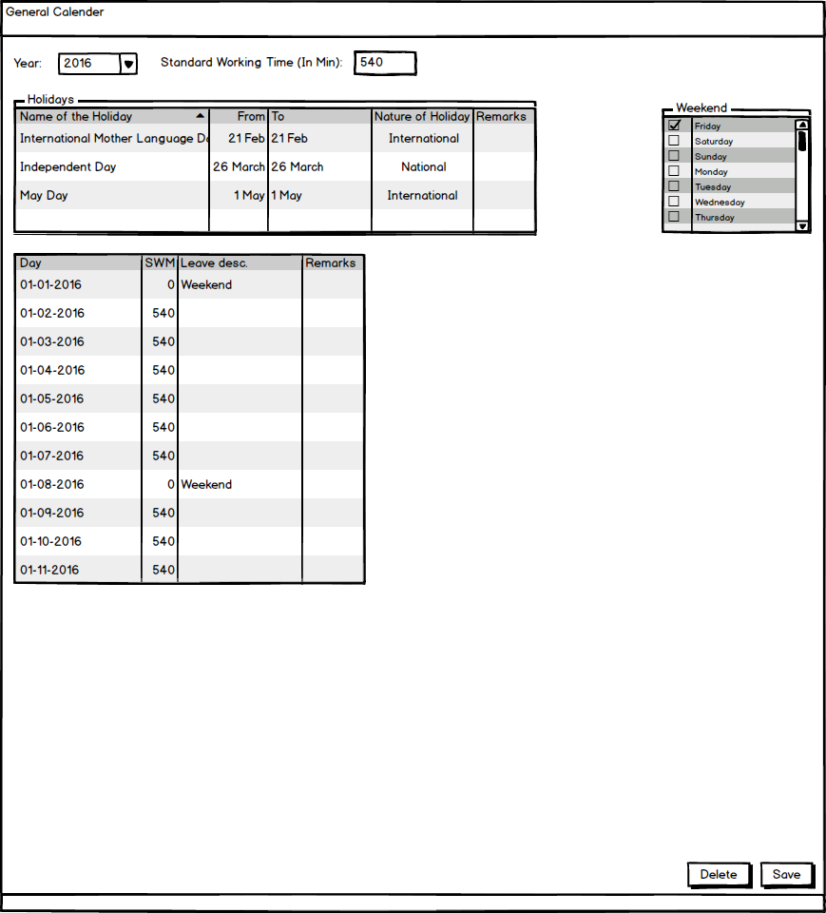

Fig: Organizational General Calendar

### Machine Block Wise Calendar:

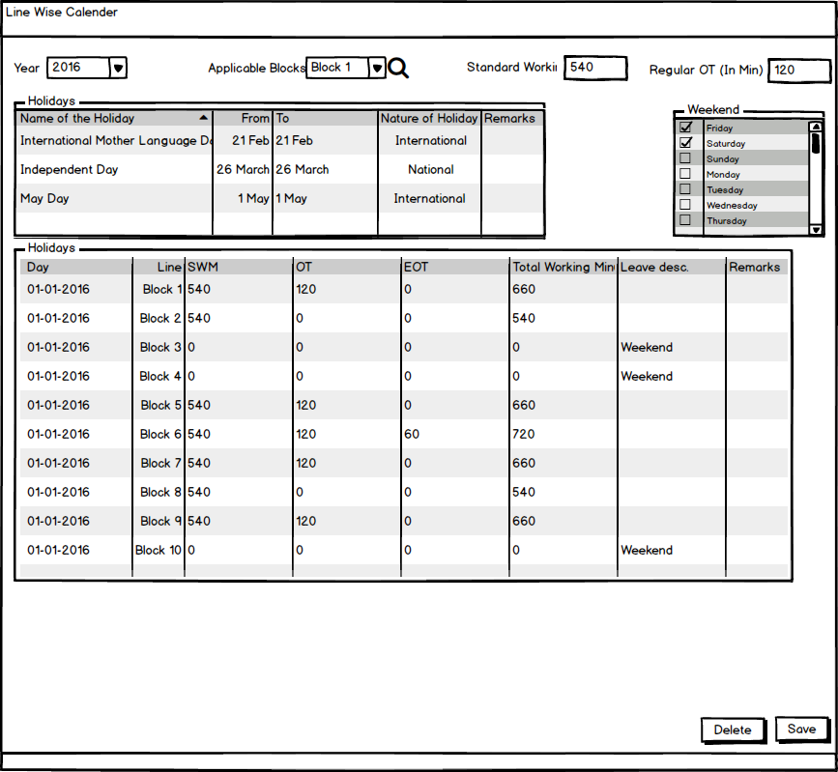

Fig: Machine Block Wise Calendar

## Production Planning Operational user interface mock-up

### Style Study

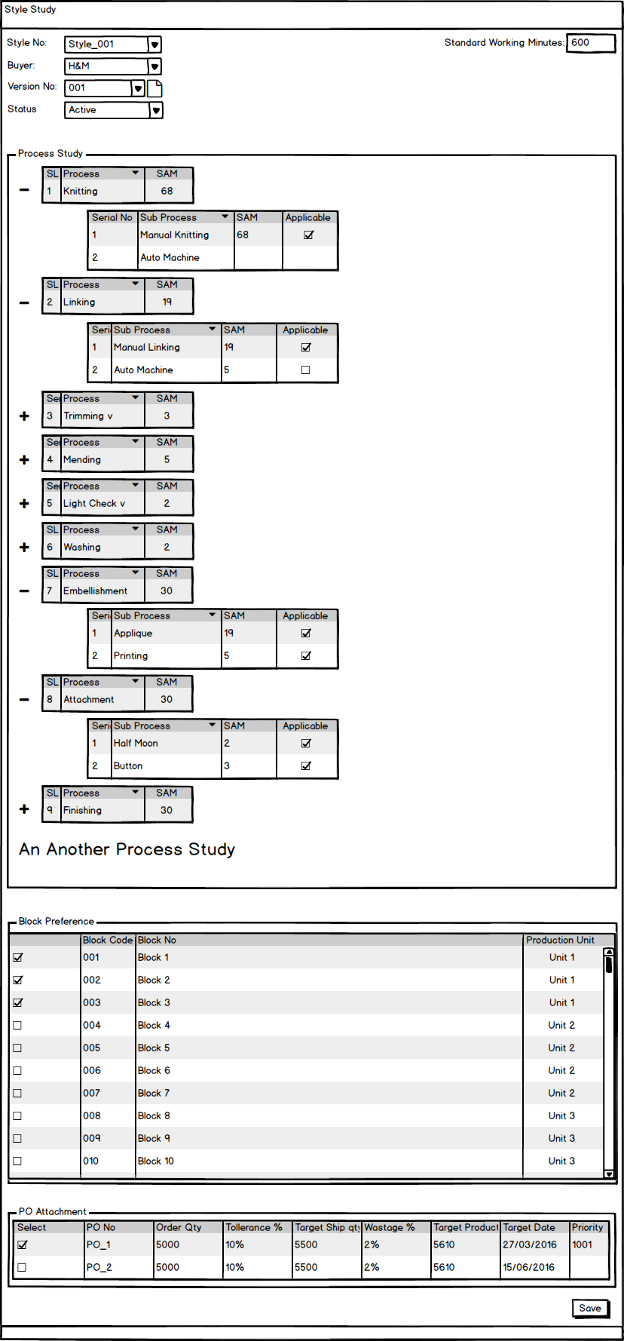

Fig: Style Study

### Buyer Work Order

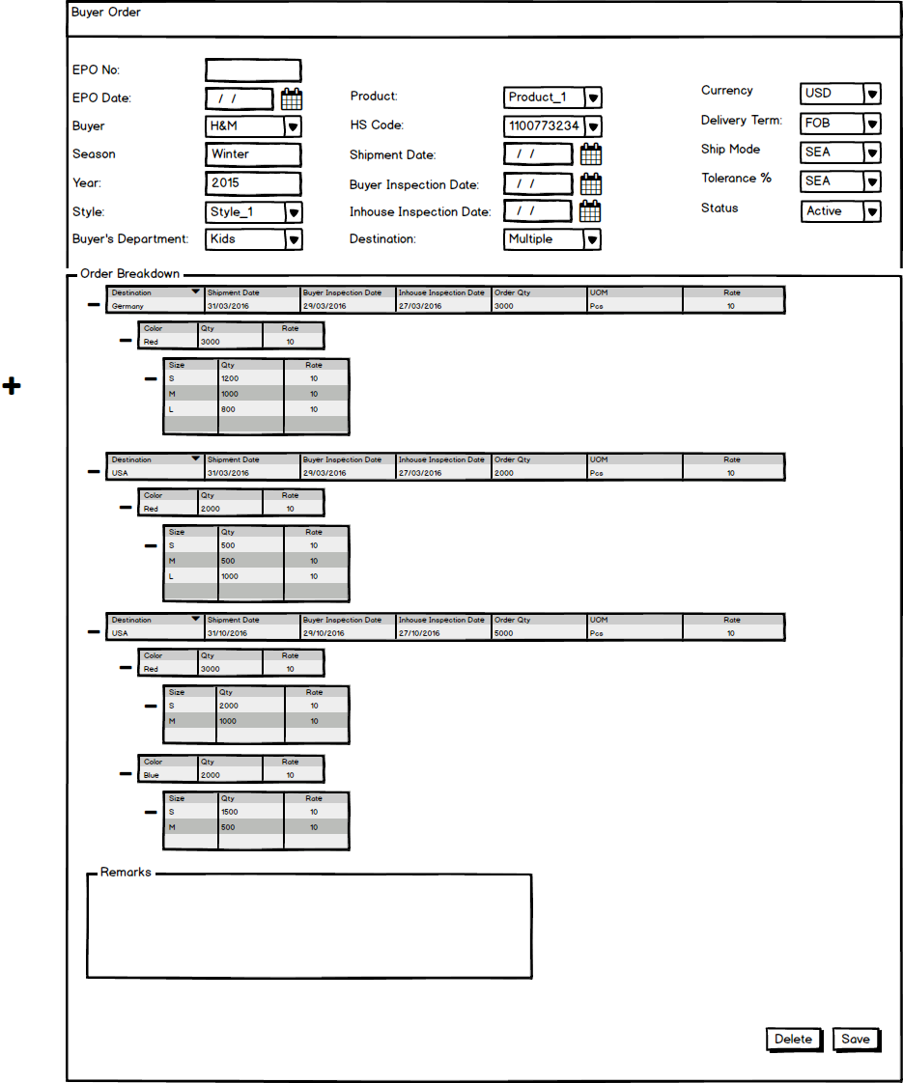

Fig: Buyer Work Order

### Planning Board

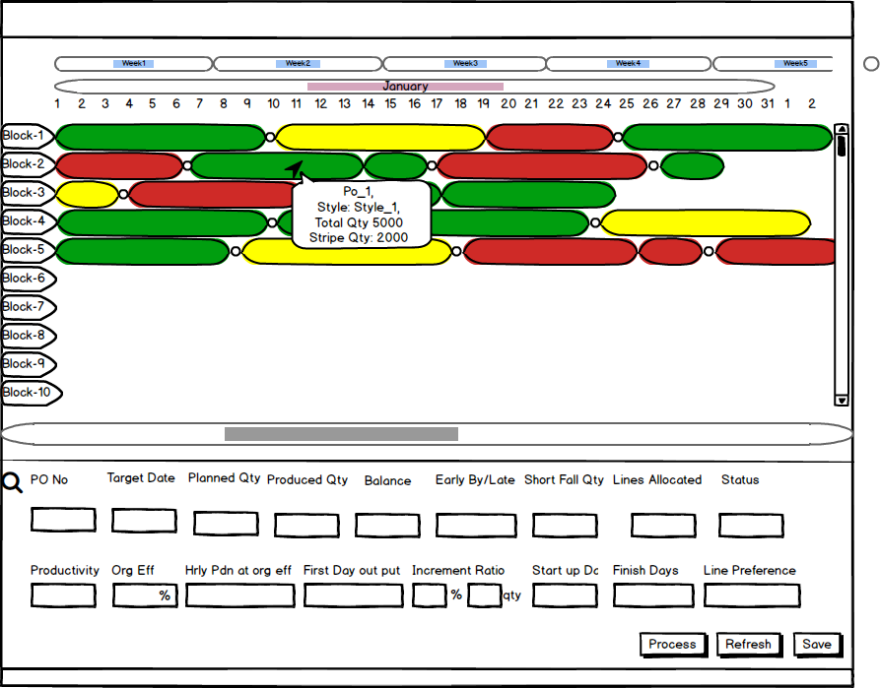

Fig: Planning Board